August, 2016

“Casey’s Corner”
© Joan Merriam

Minding Your Dog’s Manners

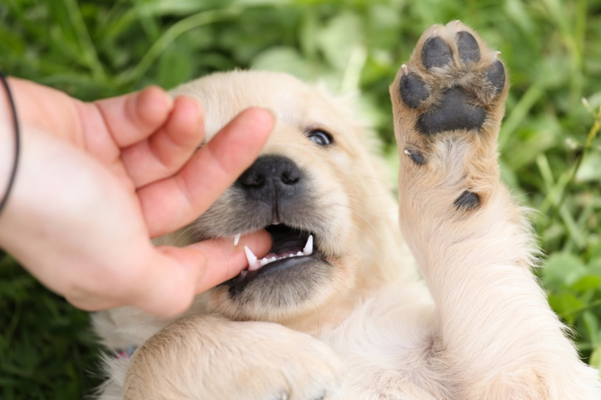
Even though school is back in session, summer is still far from over—along with all the fun summer activities we all love. Naturally, we “dog people” try to involve our pooches in as many of these activities as possible, which is a good thing. Usually.
When it’s not a good thing is when the dog in question simply doesn’t know how to behave in public…or when the owner doesn’t know how to behave with their dog in public. Either one of these scenarios usually results in other people becoming annoyed or even irate, and both you and your dog being seen as unwelcome visitors.
This has ramifications far beyond just you and your dog: whether on the trail or in the town, the more that people see dogs behaving badly and their owners overlooking that behavior, the more they complain to businesses and public officials…and the more complaints these folks receive, the more likely they are to simply ban dogs entirely to solve the problem.
Quite honestly, I don’t blame them, even though it ends up punishing everyone for the sins of a few. I don’t like it any better than you do when a 110-pound snarling, foaming-at-the-mouth Rottweiler starts dragging his owner through the store to get at me and my dog, when all we’re doing is getting a can of paint. It bugs me to no end when I see a dog “doing his business” on a sidewalk, and the human being on the other end of the leash simply looks the other way and keeps on walking. And my heart almost jolts to a stop when I unknowingly walk by a car with a partially open window and I’m suddenly confronted with a ferociously barking dog that looks like she’s going to hurl herself right through the glass.
The answer is, of course, training. (Both for the dog and the owner.) Simply put, don’t take your dog out in public if you don’t know how he’ll act: teach him what he needs to know when you’re at home, and progress from there. Don’t assume he’ll “know” how to behave properly. He doesn’t know until you teach him! That’s part of being a responsible pet owner.
The key is to make sure your dog is under your control AT ALL TIMES. If that means cutting your outing short because of bad manners, that’s what you need to do. Try again tomorrow. And the day after.
Here are a few tips to make sure that you and your dog are being “good citizens”:
- We all want our dogs to be perfect from the get-go, but it’s not fair to take her to a busy or crowded place and expect her to behave, if she hasn’t practiced in calmer spots. Start off with something like a quiet outdoor café or a park. If people will be walking by, have your dog sit or lie down on the opposite side of you; then give her treats to encourage calmness.
- When you’re in a town especially, carry (and use!) dog waste bags. No one wants to accidentally step in a “gift” your dog has left in the middle of a sidewalk.
- By the same token, if your dog has an accident in a store that permits dogs, don’t just ignore it. Tell a clerk, ask for some paper towels, and offer to clean it up yourself. (Casey once peed in the middle of a store—on carpet, no less!—and I was so mortified that I bought a bottle of Nature’s Miracle and took it to them that afternoon. As gracious as the owners were, I was still appalled it had happened.)
- In restaurants where dogs are accepted in outdoor dining areas, make sure he stays right by your side for the entire meal—no wandering around greeting other diners as if he were a celebrity chef.
- On the trail, if dogs are allowed off-leash, pay attention to other people and their dogs. Leash up your dog again if another leashed dog approaches—often, that can be a clue that the strange dog is either timid or excitable or aggressive. Also, one dog on-leash and another off-leash can sometimes spark “power politics” aggression between the two.
- Be careful not to put your pup in situations where her patience or demeanor could be challenged. For instance, you probably want to limit her exposure to a whole roomful of screeching, squealing children. One or two kids at a time are much easier for most dogs to handle, unless they’ve been trained to deal with groups of children.
- Make sure your dog is trained not to jump on or shove people. Children and the elderly can be badly hurt by a big dog that’s too enthusiastic or that simply doesn’t understand his own strength.
- Never, ever assume that you can bring your dog when you visit someone else’s home. Even if your pup is an example of impeccable canine comportment, not everyone wants a dog in their house. Always ask first…and don’t take it personally if the answer is “no”!

So here’s to good manners—in dogs and people!—and a great end-of-summer!

Joan Merriam lives in Nevada County with her Golden Retriever Joey, her Maine Coon cat Indy, and the abiding spirit of her beloved Golden Retriever Casey in whose memory this column is named. You can reach Joan at joan@joanmerriam.com. And if you're looking for a Golden, be sure to check out Homeward Bound Golden Retriever Rescue .

